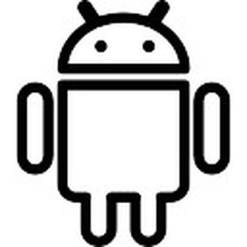
Android yes it is a amazing platform but the lack of a safe and locked down system it can leave some users a bit worried and un-sure with what is currently going on with their own device. There are a millions of developers putting a lot of work into this current platform, but what I am going to talk about today may make you re-think using the unprotected google operating system. Just the fact there are thosands of apps in the play store that is made just to make the system more secure for the end user is worring. I have been using android for the last five to six years, and have had a couple of phones break due to the fact that the operating system has no protection against any viruses.

I know that there are a lot of different virus scanner applications on the app store, but its that doggie group of app that make the android expierence worse than it actually is. I know that I can not personally attck google for this it is just what they have approved to put onto their app store after all. With IOS there is a huge lock down when a developer submits a application to be in the app store but in the google play store I know their submition system is a lot more forgiving.

I mean your phone is on your person at all time, it has two cameras. All it takes is a third party to access your camera or your location, even your photos. You put everything into your phone and it is something that should be fully restricted. “https://www.youtube.com/watch?v=og_NXY9Eu54” here is a link to a video where there is a study quoted saying the there is only 0.86% of the population of the phones in the usa has some sort of virus or malware on there. At first that might seem like a relitivley low number but it works out roughly as 2764040 people walking around with a virus on their mobile phones. This is a huge problem that we should be aware of in our every day tasks. The amount of information on yourself that your current mobile phone holds on yourself is huge amount. Imagin if some had unlimited access to that how much of it could they access and what type of damage could they cause.

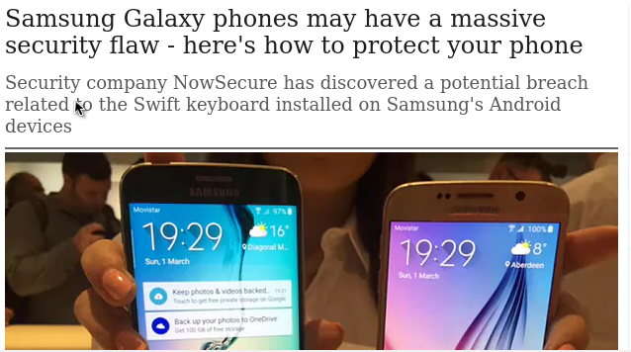
Most of the problem recently is with the third party applications. Things like third party keyboards on your mobile phone someone got access to that they could see all the information that you input into your phone. This is a problem that has occurred before with a huge amount of samsung device as well, so it is not as if it is with the small manufactured phone. These are big companies that are being targeted, and if you are already apart of that brand they your data is at risk.

Data does not seem like a very important thing anymore people freely just give out their email address without beign worried about fishing scames etc.. Your data should be protected and dear to you. I work in the mobile phone industry selling the mobiles to the front end customers, and I am yet waiting for that customer who refused to give me their email address. This may because the store I work for is a trusted sourc. Others may not even know where their information is ending up. I know of employee’s who ask for their information and before they explain why they are asking for it they had already just handed it over. I mean some people do not make the link of what you are handing over. Let me put a little enphisis on this subject. This is what you use to sign in to all of your online accounts, facebook, twitter, reddit, youtube and even financial services. If you work from home and make your money online you already may be a bit conserned with this. Even our entertainment is hosted on a server somewhere in the world and by handing over some simple pieces of information your giving someone direct access to all of that. Why should your phone be any different.

